**MIZERO TSS EXPANSION PROJECT**

To respond to the call of the Government of Rwanda to increase significantly the number of students in Technical Vocational Education and Training (TVET) schools to help young women and men to study more practical and competitive skills so as to become job creators for themselves and for their peers instead of graduating as job seekers, Jesuits established a strategic plan for upgrading the existing Technical Secondary School to have the capacity of enrolling 600 students in boarding. Most of the students enrolled come from moderate families in the country whose future depends on the quality education and practical skills they get from MIZERO. The expansion project was initiated three years ago and so far, with the constructed dormitory and some few classrooms, the school increased the number of beneficiaries from 80 to 350 students. With the needed infrastructure, MIZERO TSS will provide quality technical education to 600 students, all in boarding.

1. **Dormitories**: These are 2 dormitory units that will host 300 girls and 300 boys

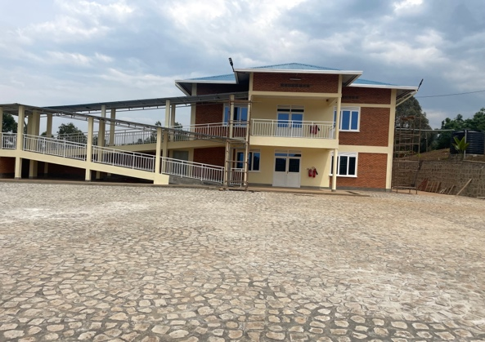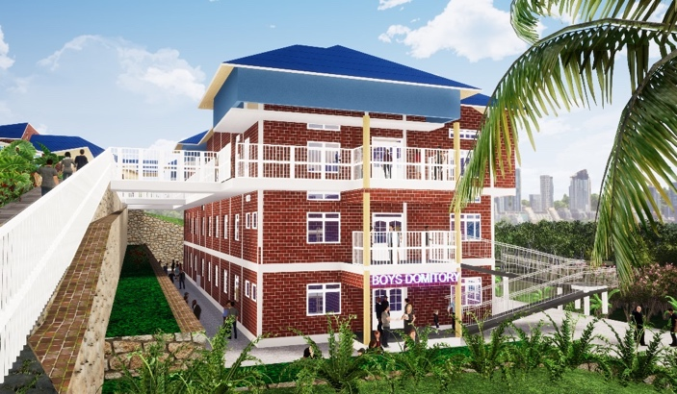

(Girls dorm constructed in 2023). (Boys dorm to be achieved in Jan 2025)

1. The Technical school will have **15 classrooms** (11 existing and 4 others to be constructed) and **four workshops for practical courses** (in project): mechanical, carpentry, masonry, welding & plumbing workshops. And the sanitaries for all the 600 students we intend to register by the academic year 2024/2025.

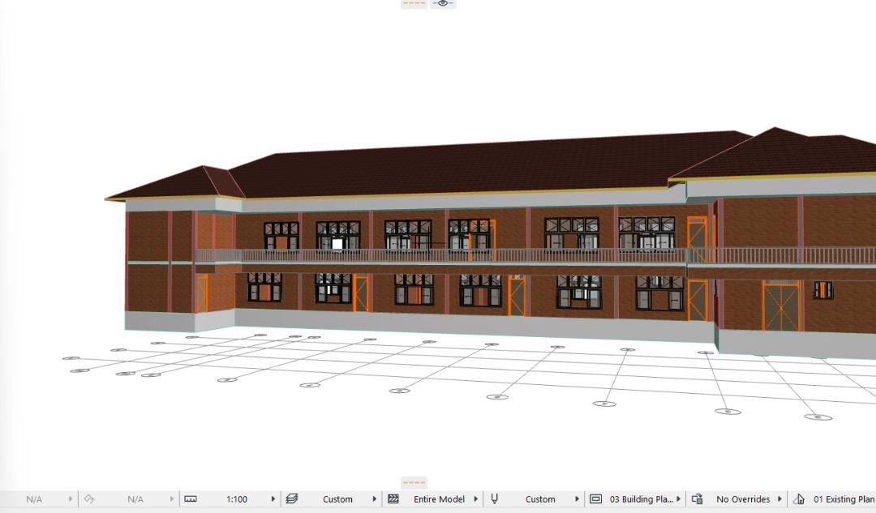

1. **Dining Hall** will help students for dining. The planned dining hall will have over 600 seats.

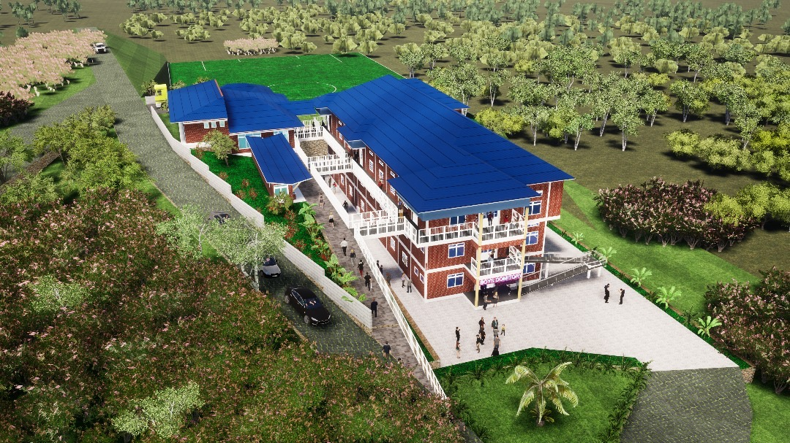

(Dining hall on the second floor of the boys’ dorm with kitchen annexed)

**Phase II**

1. **Administration bloc comprises:**

* Offices
* Teacher’s room
* Meeting room
* Library
* Bathrooms
* Kitchenette

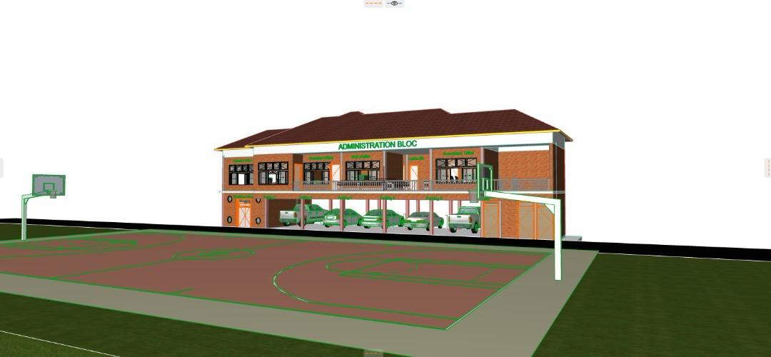

1. **A 800 seats multipurpose hall** will help for students’ entertainment and serve as source of revenue for the school by hosting different events.

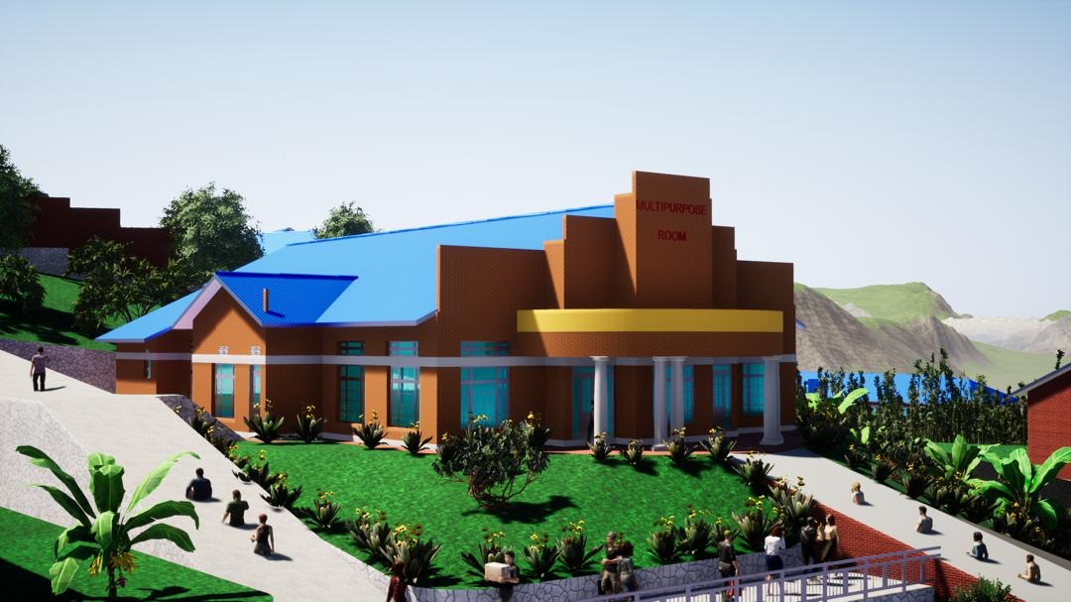

1. **Green energy** use will be our target. This will help in preserving the environment, reducing CO2 emission, and energy consumption cost.

